* Apache Kafka is Streaming platform
* 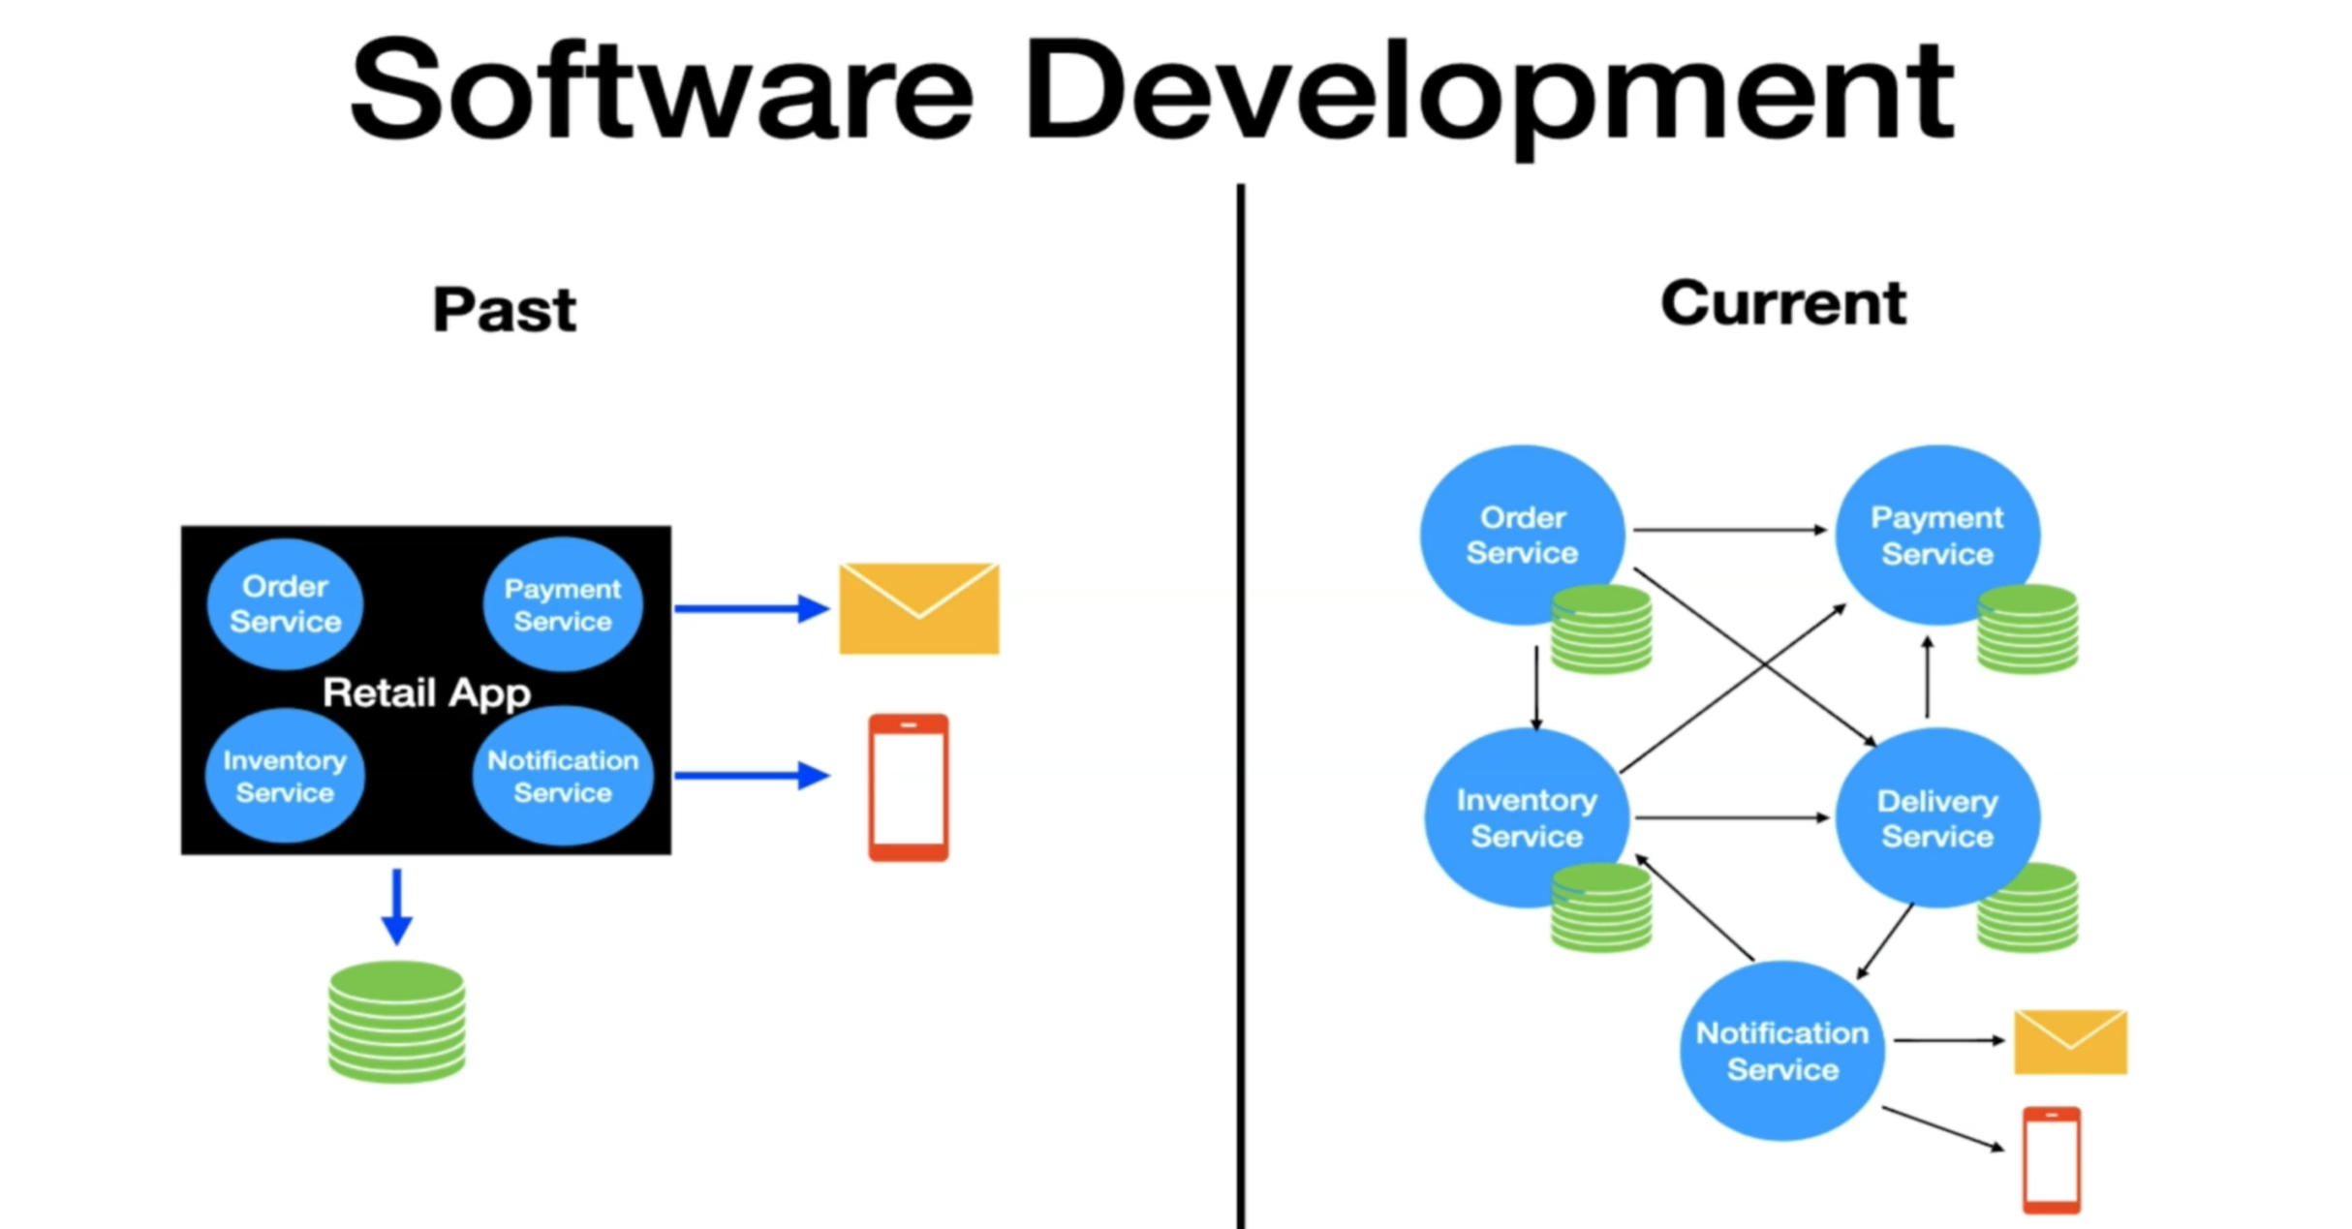
* PAST: Monolith Architecture, CURRENT: Microservice Architecture
* Today application need to provide real time notifications, in order to support that we need middleware system.
* 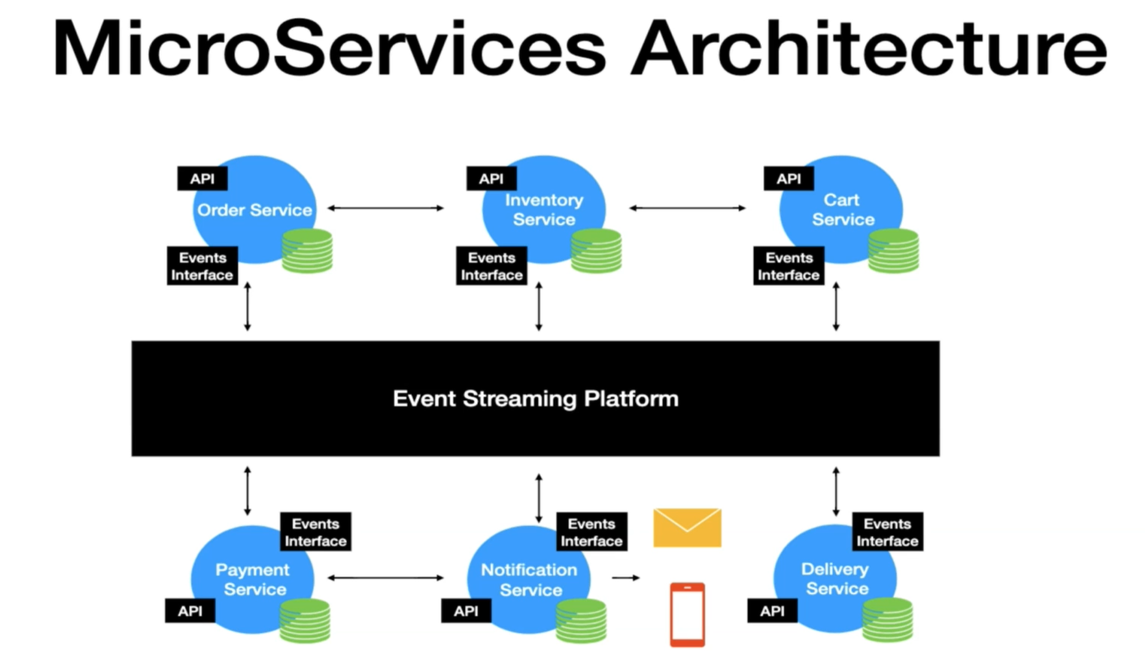
* In nutshell each microservice have API and event producer/consumer in microservice architecture.
* All services will communicate with each other using event streaming platform.
* 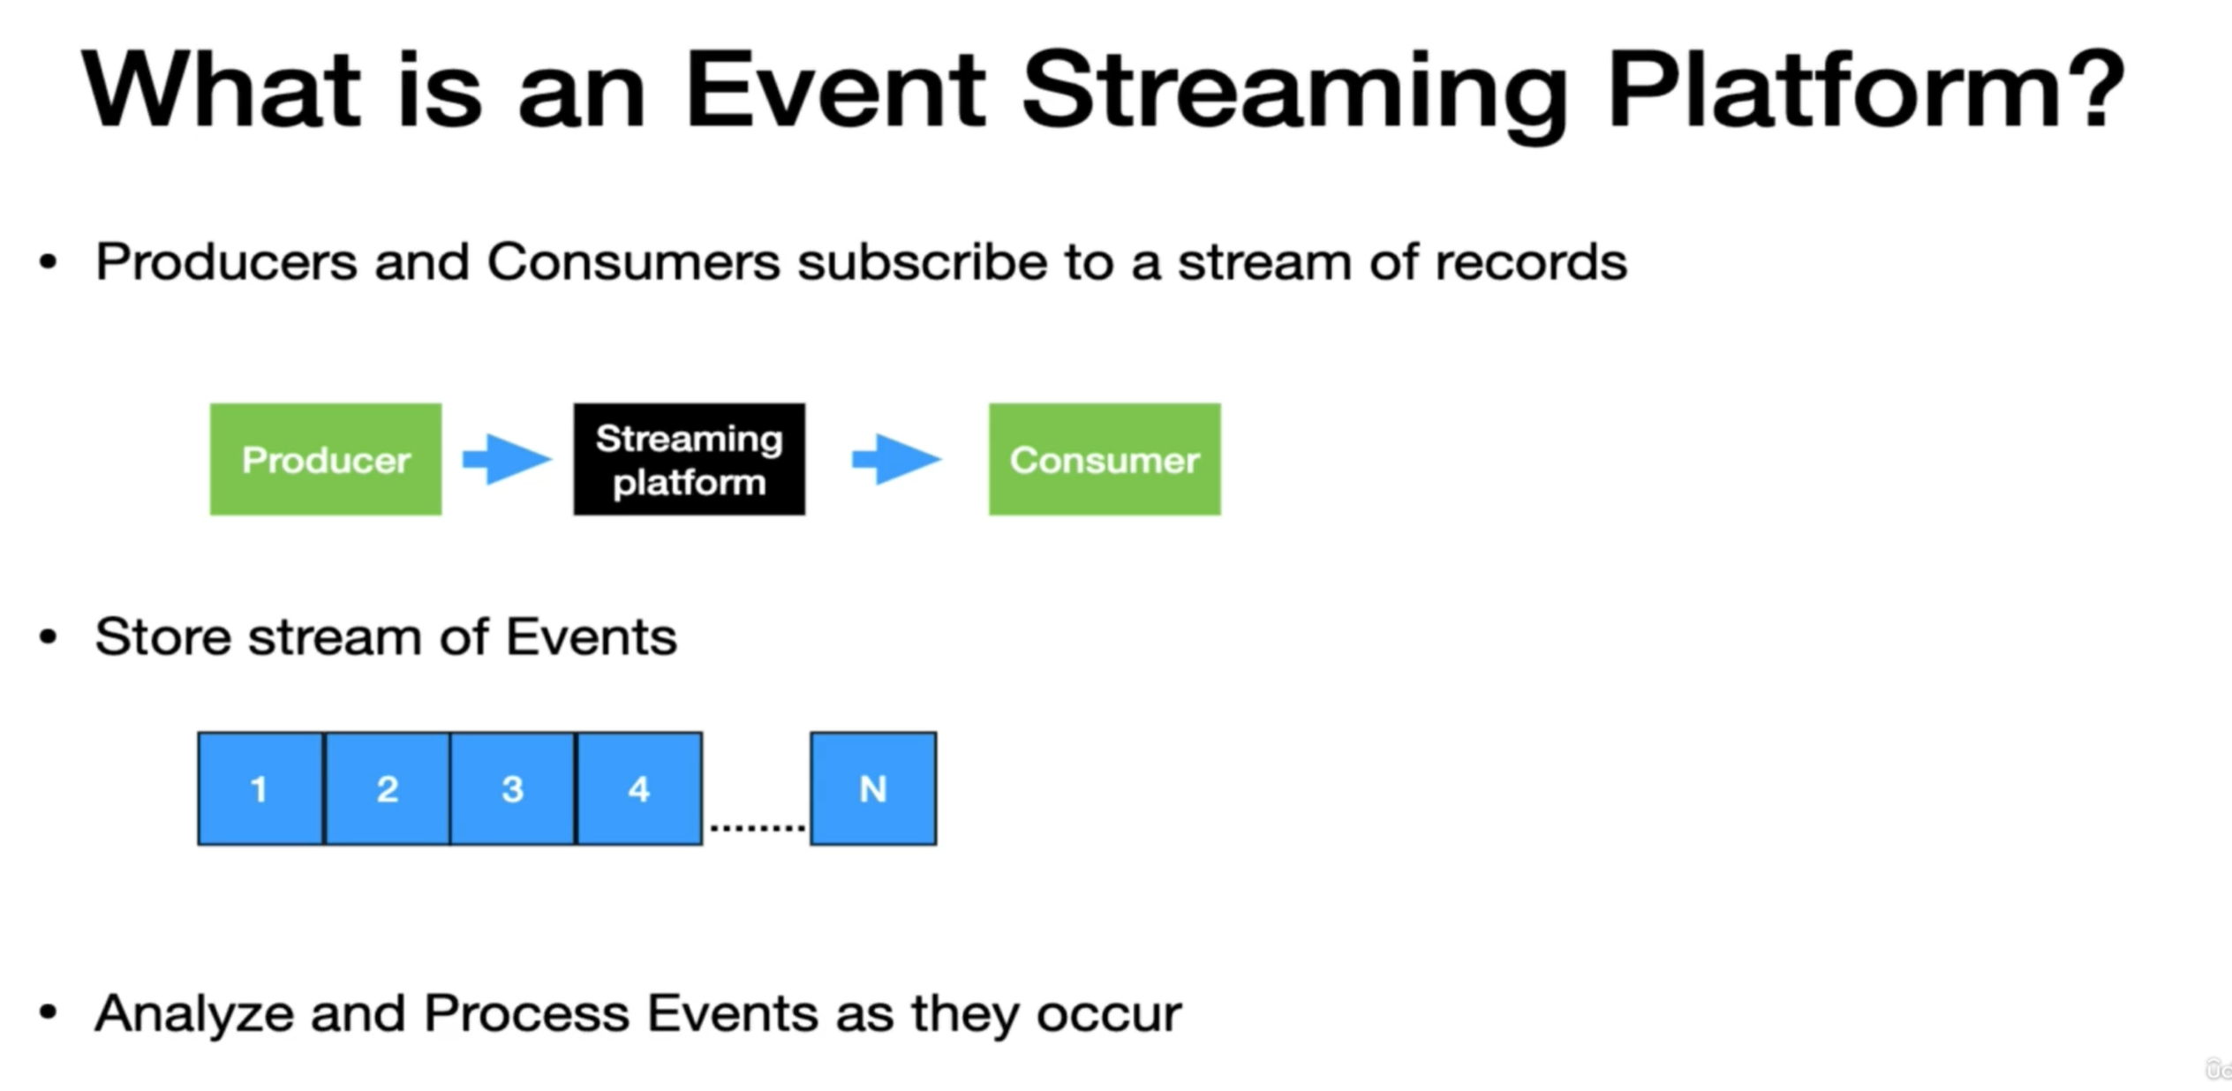
* 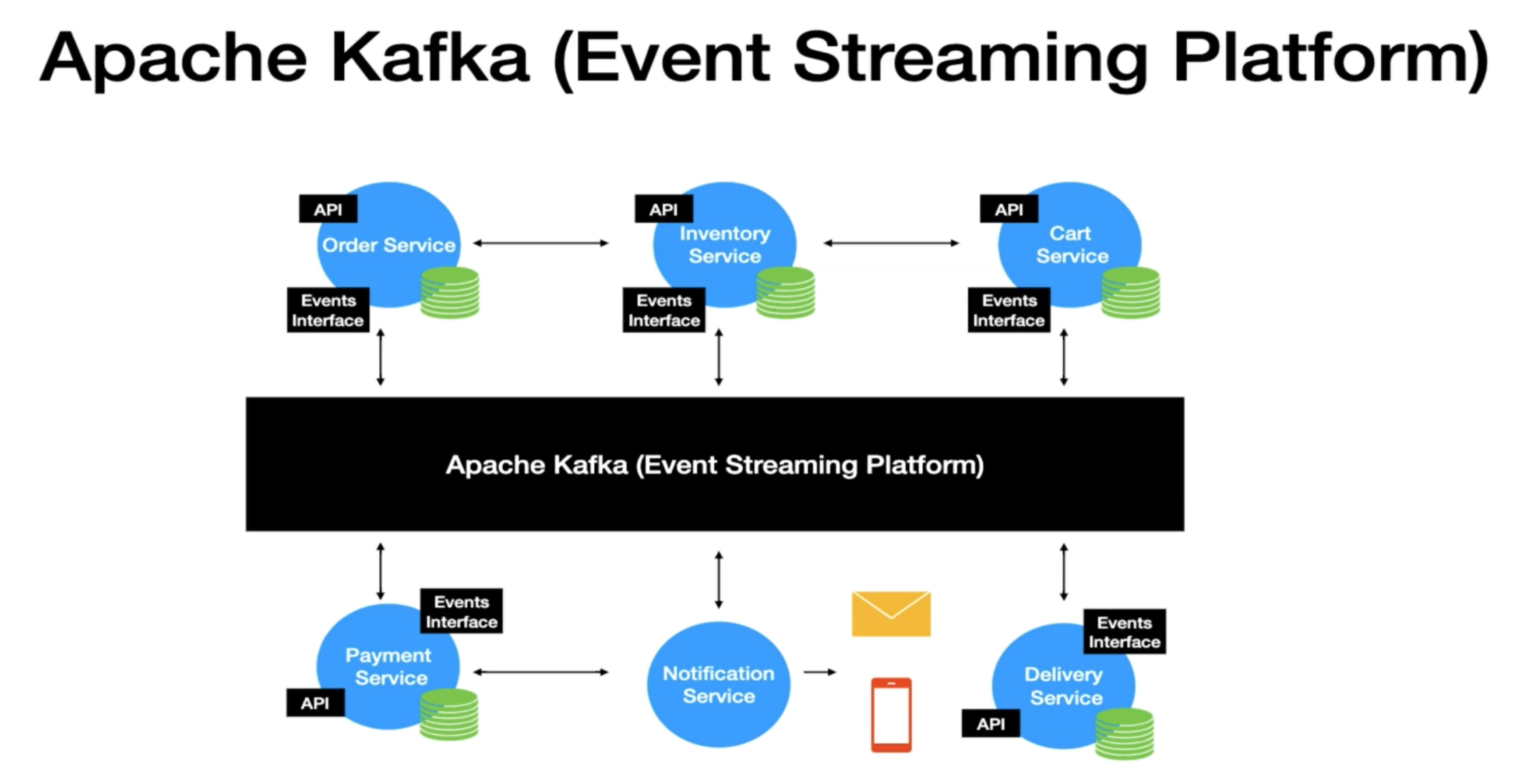
* 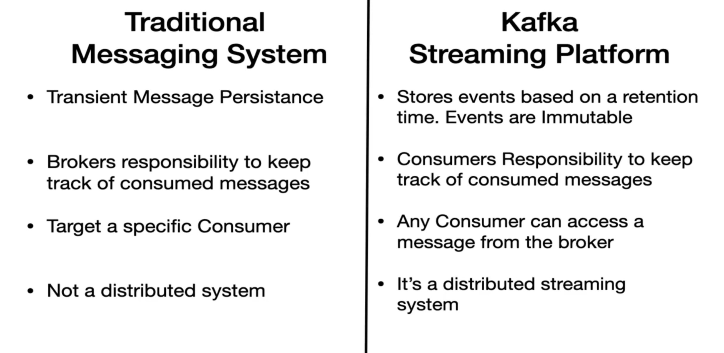
* Traditional Messaging System (TMS) is Transient Message Persistence in nature means once message is read by the consumer then it got removed from message broker.
* In Kafka events are stored in file system and they are there for certain time. All the events are immutable means once message event sent to Kafka it cannot be altered.
* In TMS its brokers responsibility to keep track of consumed messages and once message consumed remove it from broker.
* In Kafka its consumers responsibility to keep track of consumed messages.
* In TMS we target a specific consumer.
* In Apache Kafka Any consumer can access a message from the broker.
* TMS not a distributed system where as Kafka is distributed streaming system.
* 